15th North-America Europe Data Exchange Group
EUMETSAT Status Report

1. Meteosat Transition Programme

The current operational Meteosat Transition Programme has recently been extended until the end of 2005. The service is currently comprised of three satellites. Meteosat-7 provides the nominal operational service at 0º and Meteosat-5 provides the Indian Ocean Data coverage service. Meteosat-6 is the current backup for Meteosat-7 and provides 10 min. rapid scan imagery and products on a best effort basis. Table 1 presents the three satellites with their location, inclination and current available fuel.

Table 1. The three MTP satellites.
Satellite | Location | Inclination | Fuel (kg)
Meteosat-7 | 0º | 0.39º | 16.2
Meteosat-6 | 10º W | 2.1º | 8.6
Meteosat-5 | 63⁰ E | 5.1º | 5.3

The current available fuel on Meteosat-5 and –6 does not permit any further inclination manoeuvres as roughly 4 – 5 kg fuel is required to de-orbit the satellite. The inclination of these two satellites will therefore continue to increase. Figure 1 shows the current inclination and drift rates of Meteosat 5.
Figure 1. The inclination and longitude drift rate of Meteosat-5.

The services provided by the MTP satellites are:
- Image Acquisition, Rectification and Dissemination
- Data Collection and Re-transmission (only 0º)
- Meteorological Data Distribution(only 0º)
- Meteorological Products Extraction (Moving to synoptic times 1.7.2002
- Rapid Scan Products (Only 10ºW, best effort basis)

Furthermore the Eumetsat is providing a Reprocessing Facility that currently is foreseen to reanalyse 10 years of Meteosat-2 and –3 data in support of the ECMWF ERA-40 project. The Reprocessing Facility will also be utilised to derive the Meteosat Surface Albedo product for the years 1997 – 2001.

The Eumetsat Core Facility is currently maintaining a high availability of services. Generally the availability is over 98% and for some items even 99.99% (Table 2). It should be noted however that these figures do not contain scheduled outages due to e.g. spacecraft manoeuvres, or eclipse.

Table 2. The availability of the 0º and IODC services.

With respect to product generation there have been some modifications. As of 1 July 2002 all products will be generated at the synoptic hours instead of the 1 hour shift to an earlier time that was used before. The calibration of all satellites is now based on the black-body calibration of Meteosat-7 that has been operational since May 2000. For Meteosat-5 and -6 the calibration is established via cross-calibration to Meteosat-7 and provides a much more stable calibration than the previous operational vicarious calibration.

2. Meteosat Second generation

The current launch date for Meteosat Second Generation (MSG) is 27 August. It is currently foreseen that commissioning will start in autumn 2002 and the satellite will become fully operational by mid-2003.
Figure 2. The schedule for Meteosat Second Generation.

The current activities incorporate the validation of the MSG Meteorological Products Extraction Facility. The pre-launch activities targeted to ensure that the derived products meet the Day-1 requirements include the validation of the baseline algorithms and impact testing (performance of hardware, interaction with the Core Ground Segment) using simulated MSG data. The outcome of these activities is an established Day-1 configuration that will be re-validated with real MSG data during commissioning. The post-launch activities also include further validation of the scientific algorithm and tuning of the whole system.

3. Eumetsat ATOVS Retransmission Service

Based on European user requests Eumetsat is currently implementing, in co-operation with NOAA-NESDIS, MSC and European partners an ATOVS Re-transmission Service. The current baseline is that Eumetsat will provide an AAPP processing facility that will be implemented at suitable locations at the receiving stations, providing level 1B data that is transmitted to Eumetsat via a IP-VPN network. From Eumetsat the data is re-directed to the uplink station broadcasting the data to the users using DVB techniques (Figure 3). The current timeliness for the data is 30 min after measurement.
Figure 3. The Eumetsat ATOVS Re-transmission Service

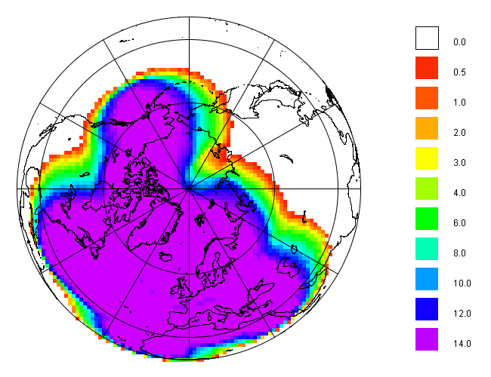The re-transmission service provides a near real-time coverage for most of the Northern hemisphere as illustrated by Figure 4.
Figure 4. The Eumetsat ATOVS Re-transmission Service coverage.
4. METOP-1

The majority of instruments (FM or EM) have been integrated on METOP-1 and currently the launch is planned for mid-2005 on a Soyuz launcher from Baikonour. The Critical Design Review of the Core Ground Segment is also ongoing and the installation of the CGS is planned to start mid-2003. The antenna is being erected at the site on Svalbard and work is expected to be completed during the summer window in 2002. First Satellite System Validation Test SSVT1 (SVM) are planned for mid-2003.

5. JASON-2

The JASON –2 programme is a joint programme with CNES, NASA and NOAA. The aim is to provide high-quality observations about ocean surface (topography, waves etc.) for climate and oceanography using C/Ku-Band Radar technology. The satellite will have a 60° inclination orbit and precise orbit determination are provided with DORIS ground beacons. JASON-2 is the operational continuation of CNES/NASA JASON-1 that was launched in December 2001 with NOAA taking the leading operational role in JASON-2. The launch of Jason-2 is currently planned for December 2006. The Eumetsat involvement in JASON-2 is has been enabled as an optional programme. The subscription by member states has already started. Eumetsat will provide hosting, monitoring and 1st line maintenance of an Earth Terminal for payload data and commanding. Furthermore Eumetsat will assume responsibility for processing and distributing NRT operational products, based on product processing delivered from CNES.

